# 

**{{Quote_Number}}**

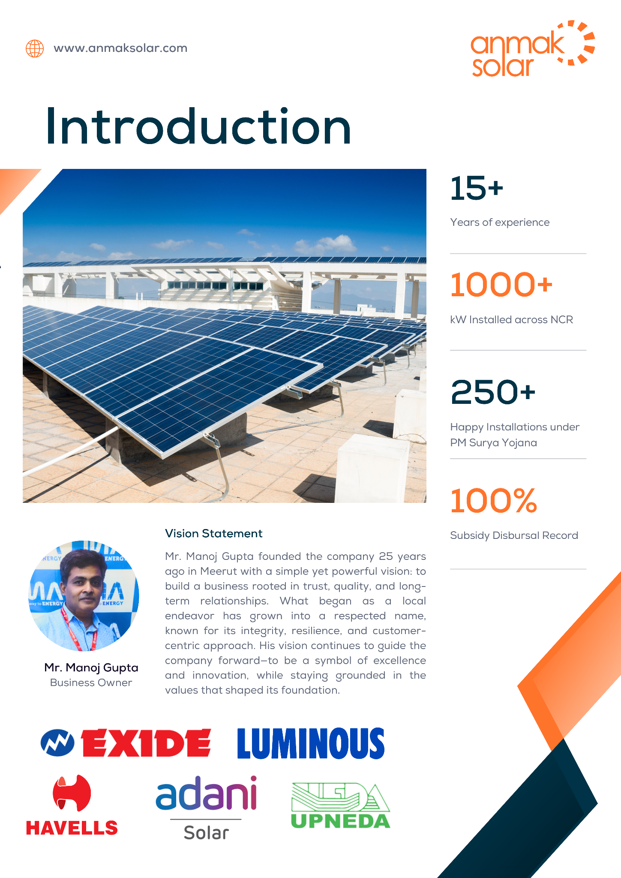

|  | | **KAMNA TRADERS**  72 ,BUDHA VIHAR COLONY NEAR SURAJ KUND  ROAD , MEERUT  Uttar Pradesh 250002 India  GSTIN - 09ADUPG9238P1ZG  9412200346  [sales@anmaksolar.com](mailto:sales@anmaksolar.com)  [www.anmaksolar.co](http://www.anmaksolar.com/)m | | | | | | | | Quotation | | |
| --- | --- | --- | --- | --- | --- | --- | --- | --- | --- | --- | --- | --- |
| Quote Reference #  Quote Date | | **: {{Quote_Number}}**  **: {{Quote_Date}}** | | | | Place Of Supply | | | | **: Uttar Pradesh (09)** | | |
| **Bill To** | | | | | | | | | | | | |
| **{{Customer_Name}}**  {{Cust_Address}} | | | | | | | | | | | | |
| **#** | **Item & Description** | | | | | | | | | | | **Amount** |
|
| 1 | **{{Product_Name}}**  **{{Items}}**  **Net Metering:** **Included**  **Installation:** **Included** | | | | | | | | | | | {{Cust_Price}} |
|
| **Terms & Conditions -**  1. PAYMENT 100 % ADVANCE AGAINST ORDER  2. DELIVERY CHARGES EXTRA AS APPLICABLE*  3. THIS QUOTATION IS VALID FOR 7 DAYS FROM THE DATE OF ISSUE  4. PANEL CAPACITY MAY VARY BY ±2%.  5. IF ANY TAMPERING OCCURS WITHIN 5 YEARS OF THE INSTALLATION DATE OR IF ANY EXTERNAL MODULE IS INSTALLED, THE WARRANTY WILL BE VOID.  **Notes -**  BANK OF BARODA ,VALLEY BAZAR ,MEERUT  A/C: 14740400000223 , IFSC: BARB0VALLEY    SCAN TO PAY  ( kamna79061@barodampay ) | | | | | | | |  |  | Sub Total  CGST0 (0%)  SGST0 (0%)  **Total** | | {{Cust_Price}}  0.00  0.00 |
|  |  | **{{Cust_Price}}** |
|  | | | | |
|  | | | | |
| Authorized Signature | | | | |
|
|

